Test Case: tc002_SPX_Dev5_Crear_Requisicion_Spot_Con_FAD_Tipo_Cobro_CC
Step 1 - Enter username and password and click to button Enter : Credentials Entered
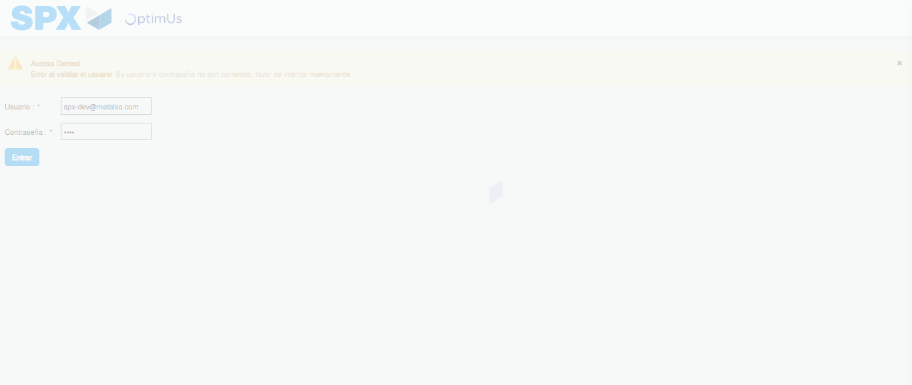Image file-name: QC_Testing-tc002_SPX_Dev5_Crear_Requisicion_Spot_Con_FAD_Tipo_Cobro_CC-1790177306737

Step 2 - Select to UEN and Access to Spot Buy Requisitions : UEN Correctly selected and Correct access
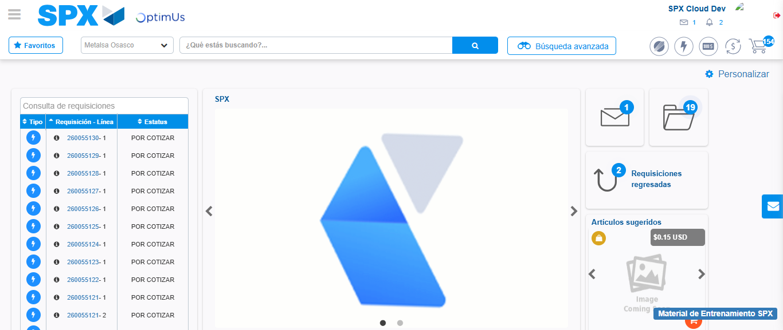Image file-name: QC_Testing-tc002_SPX_Dev5_Crear_Requisicion_Spot_Con_FAD_Tipo_Cobro_CC-1790177337506

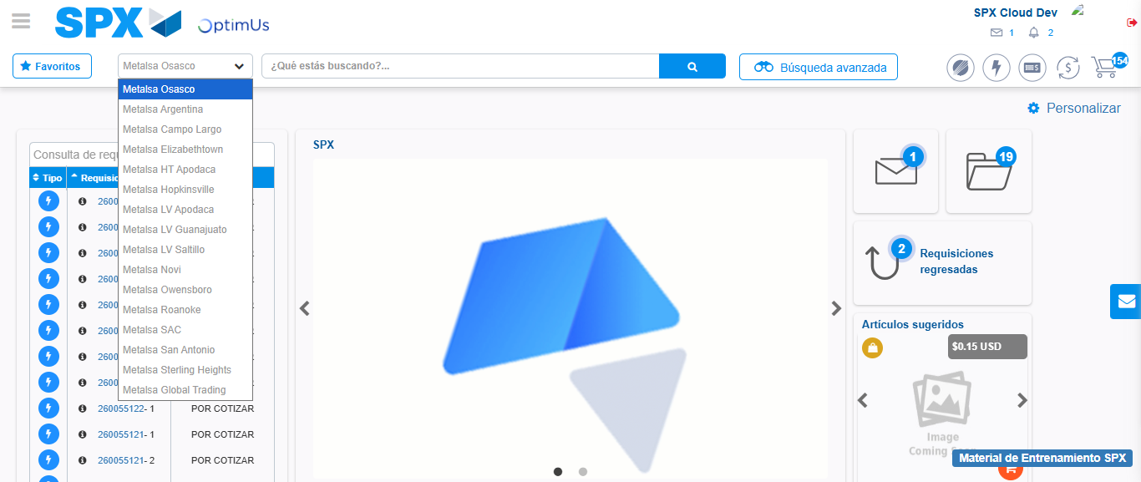Image file-name: QC_Testing-tc002_SPX_Dev5_Crear_Requisicion_Spot_Con_FAD_Tipo_Cobro_CC-1790177338103

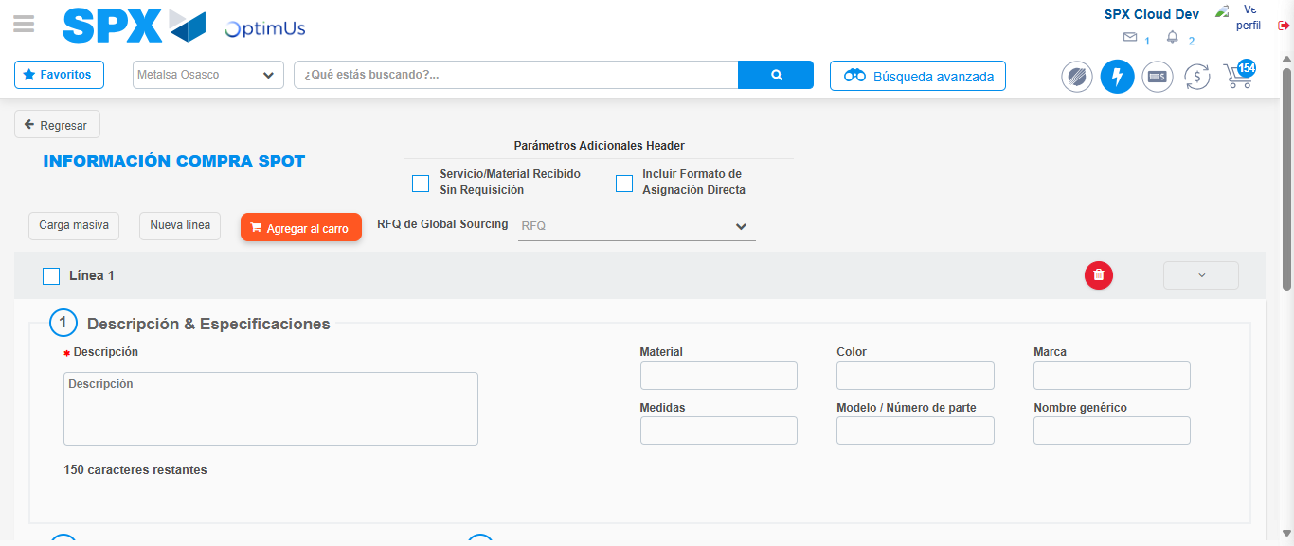Image file-name: QC_Testing-tc002_SPX_Dev5_Crear_Requisicion_Spot_Con_FAD_Tipo_Cobro_CC-1790177342470

Step 3 - Add FAD to Requisition: FAD Successfully Added
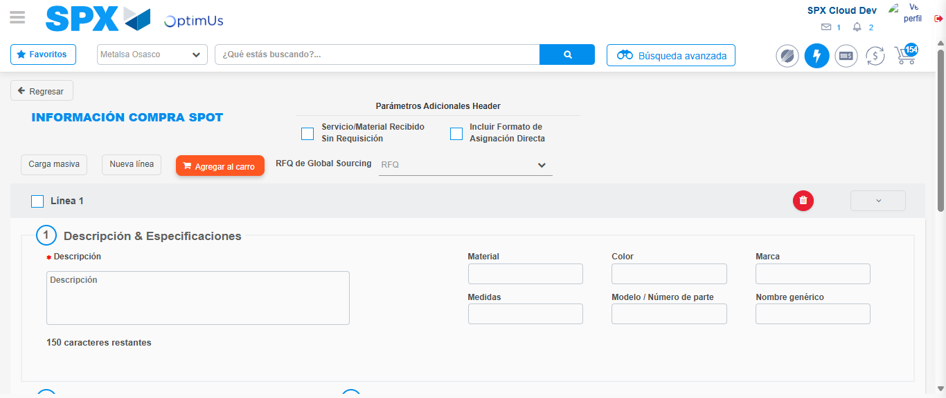Image file-name: QC_Testing-tc002_SPX_Dev5_Crear_Requisicion_Spot_Con_FAD_Tipo_Cobro_CC-1790177342806

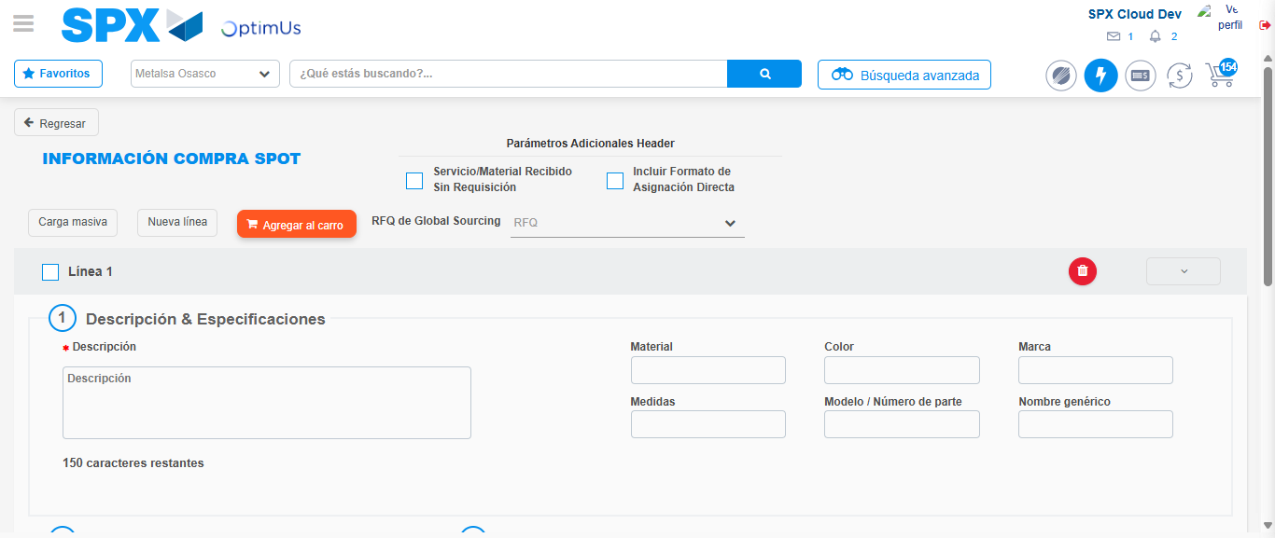Image file-name: QC_Testing-tc002_SPX_Dev5_Crear_Requisicion_Spot_Con_FAD_Tipo_Cobro_CC-1790177343024

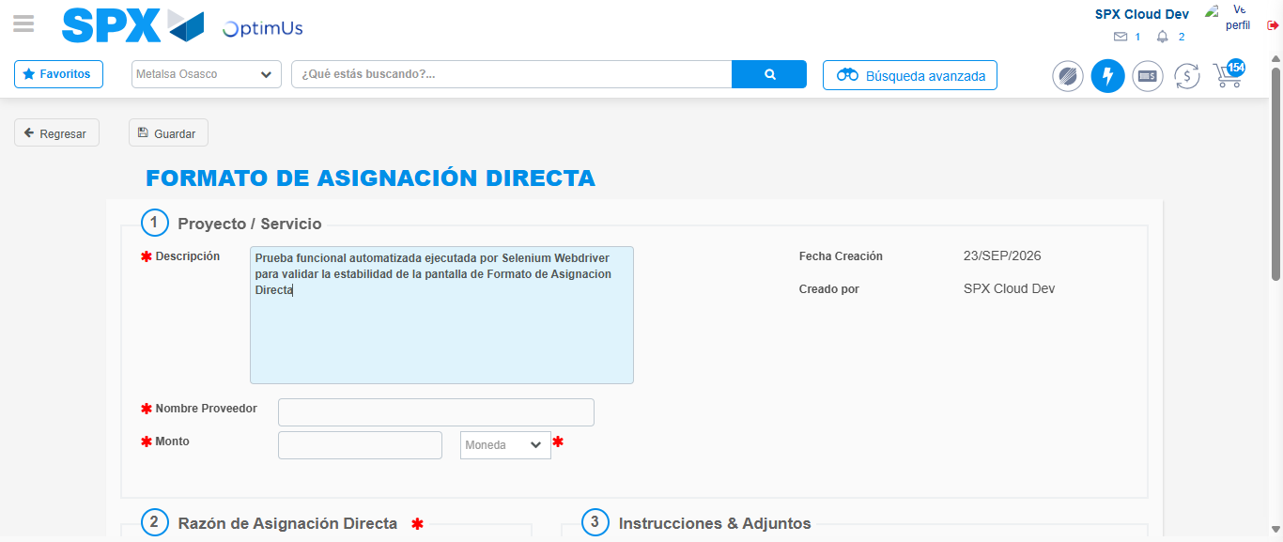Image file-name: QC_Testing-tc002_SPX_Dev5_Crear_Requisicion_Spot_Con_FAD_Tipo_Cobro_CC-1790177345823

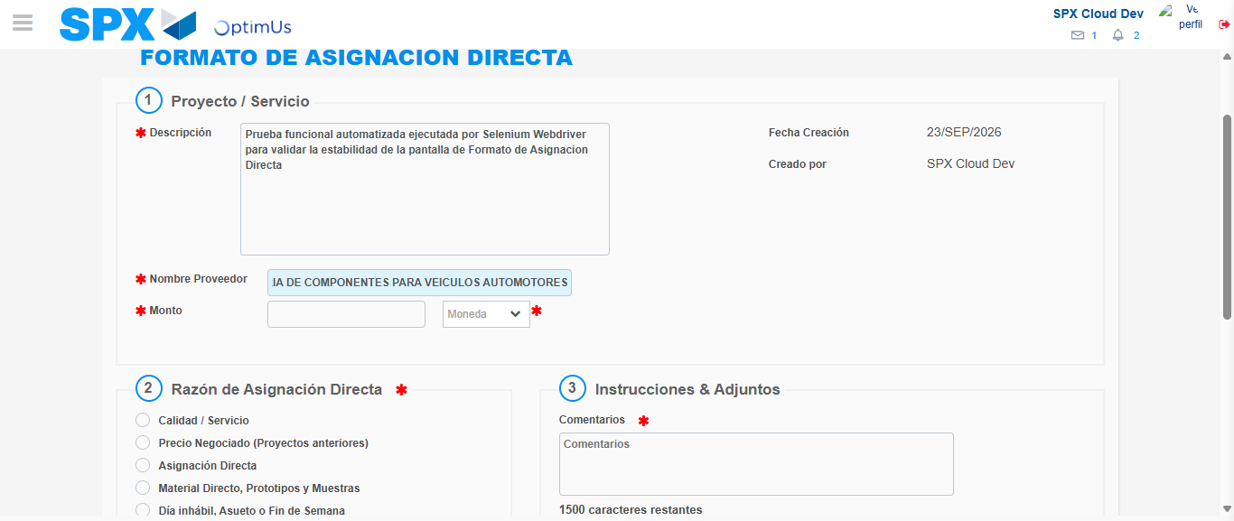Image file-name: QC_Testing-tc002_SPX_Dev5_Crear_Requisicion_Spot_Con_FAD_Tipo_Cobro_CC-1790177354409

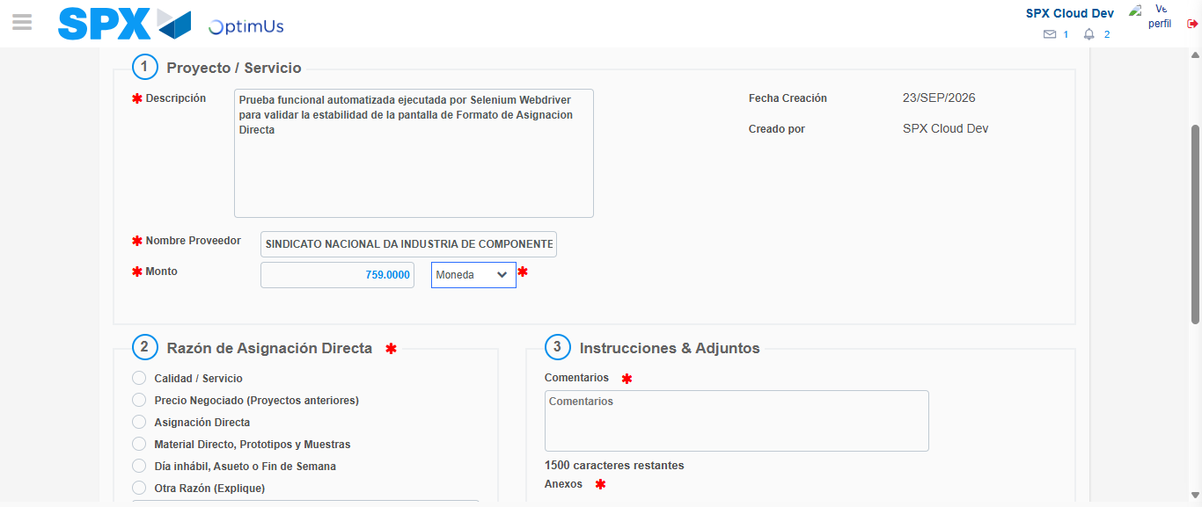Image file-name: QC_Testing-tc002_SPX_Dev5_Crear_Requisicion_Spot_Con_FAD_Tipo_Cobro_CC-1790177354808

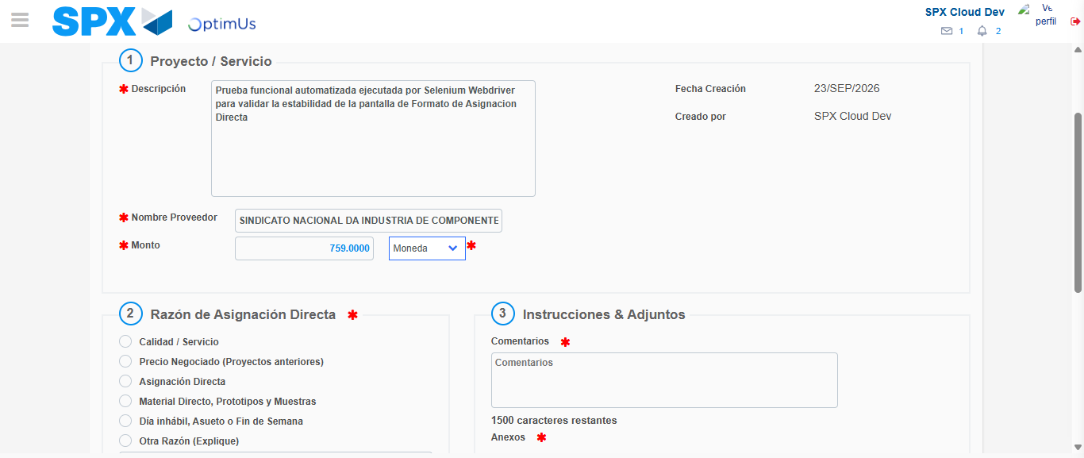Image file-name: QC_Testing-tc002_SPX_Dev5_Crear_Requisicion_Spot_Con_FAD_Tipo_Cobro_CC-1790177355038

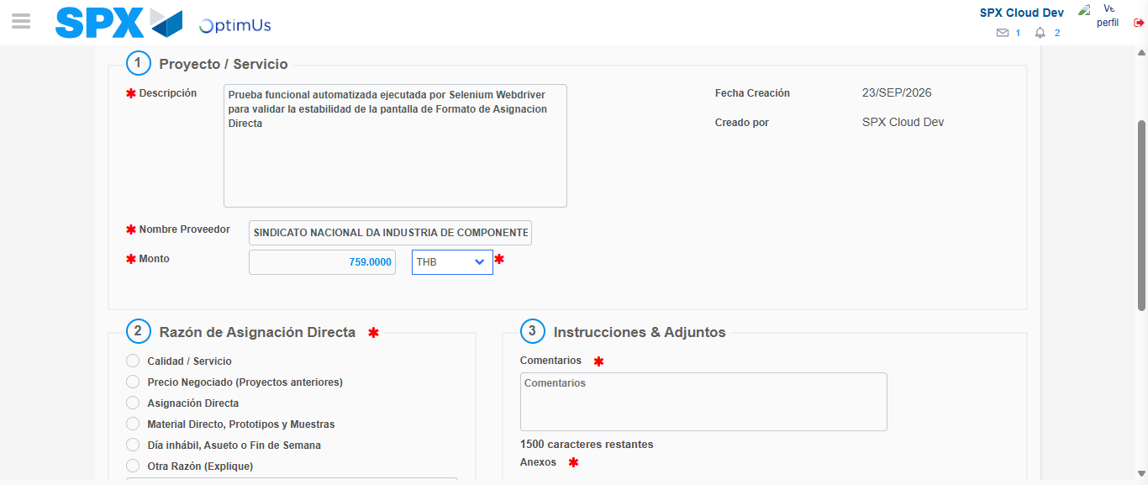Image file-name: QC_Testing-tc002_SPX_Dev5_Crear_Requisicion_Spot_Con_FAD_Tipo_Cobro_CC-1790177355348

Image file-name: QC_Testing-tc002_SPX_Dev5_Crear_Requisicion_Spot_Con_FAD_Tipo_Cobro_CC-1790177355519

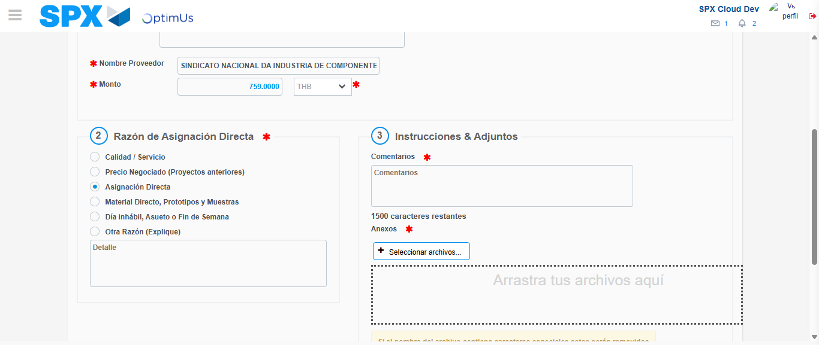Image file-name: QC_Testing-tc002_SPX_Dev5_Crear_Requisicion_Spot_Con_FAD_Tipo_Cobro_CC-1790177356326

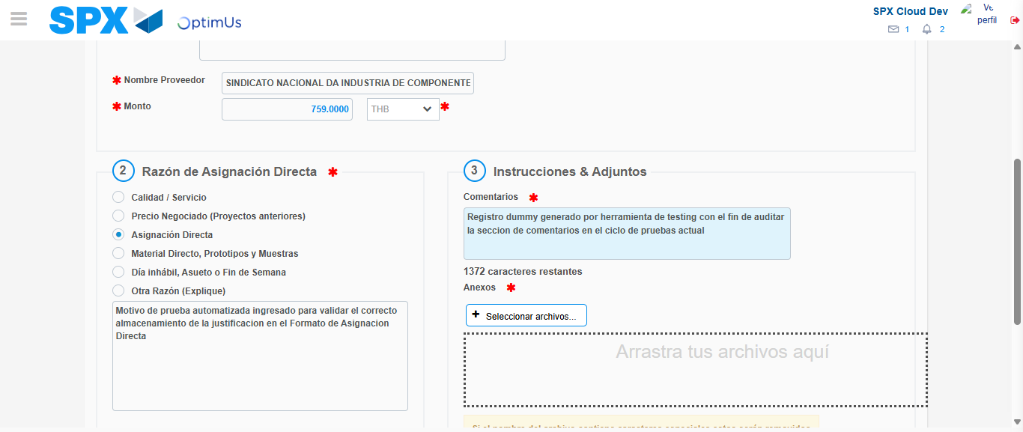Image file-name: QC_Testing-tc002_SPX_Dev5_Crear_Requisicion_Spot_Con_FAD_Tipo_Cobro_CC-1790177367314

Image file-name: QC_Testing-tc002_SPX_Dev5_Crear_Requisicion_Spot_Con_FAD_Tipo_Cobro_CC-1790177368152

Step 4 - Data Capture Spot Buy Requisition: Data captured correctly
Image file-name: QC_Testing-tc002_SPX_Dev5_Crear_Requisicion_Spot_Con_FAD_Tipo_Cobro_CC-1790177342806

Image file-name: QC_Testing-tc002_SPX_Dev5_Crear_Requisicion_Spot_Con_FAD_Tipo_Cobro_CC-1790177343024

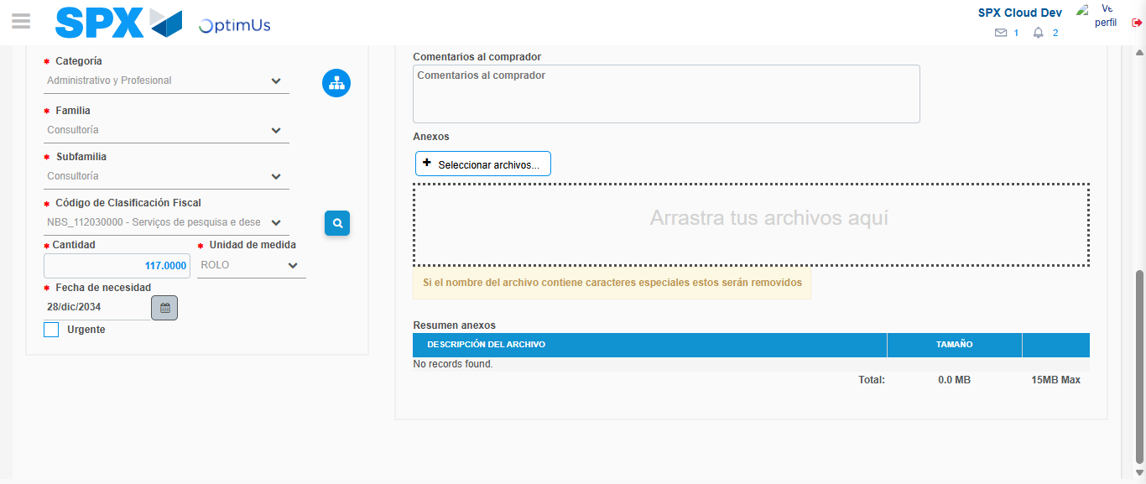Image file-name: QC_Testing-tc002_SPX_Dev5_Crear_Requisicion_Spot_Con_FAD_Tipo_Cobro_CC-1790177385378

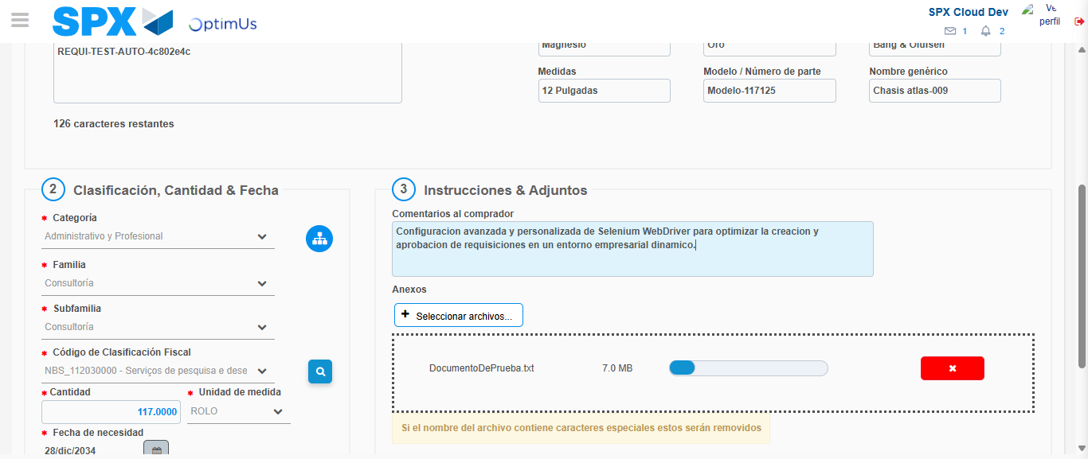Image file-name: QC_Testing-tc002_SPX_Dev5_Crear_Requisicion_Spot_Con_FAD_Tipo_Cobro_CC-1790177386125

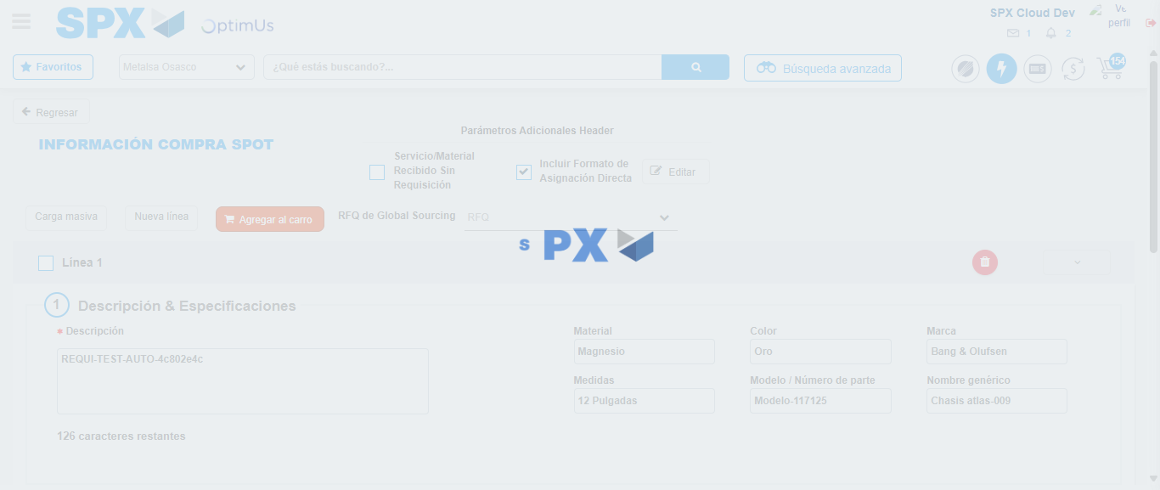Image file-name: QC_Testing-tc002_SPX_Dev5_Crear_Requisicion_Spot_Con_FAD_Tipo_Cobro_CC-1790177406653

Step 8 - Return to Main Page SPX : Return to Main Page SPX
Image file-name: QC_Testing-tc002_SPX_Dev5_Crear_Requisicion_Spot_Con_FAD_Tipo_Cobro_CC-1790177337506

Image file-name: QC_Testing-tc002_SPX_Dev5_Crear_Requisicion_Spot_Con_FAD_Tipo_Cobro_CC-1790177338103

Image file-name: QC_Testing-tc002_SPX_Dev5_Crear_Requisicion_Spot_Con_FAD_Tipo_Cobro_CC-1790177342470

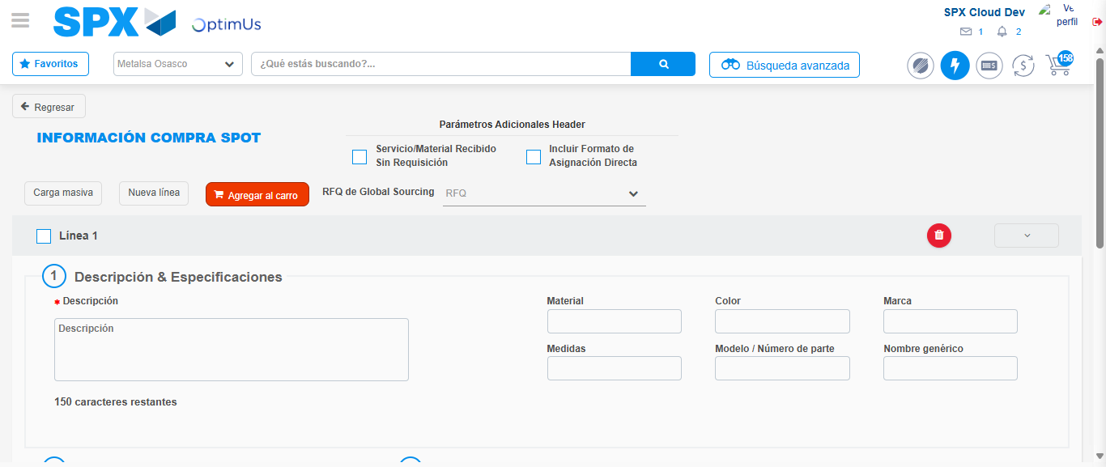Image file-name: QC_Testing-tc002_SPX_Dev5_Crear_Requisicion_Spot_Con_FAD_Tipo_Cobro_CC-1790177428964

Image file-name: QC_Testing-tc002_SPX_Dev5_Crear_Requisicion_Spot_Con_FAD_Tipo_Cobro_CC-1790177429137

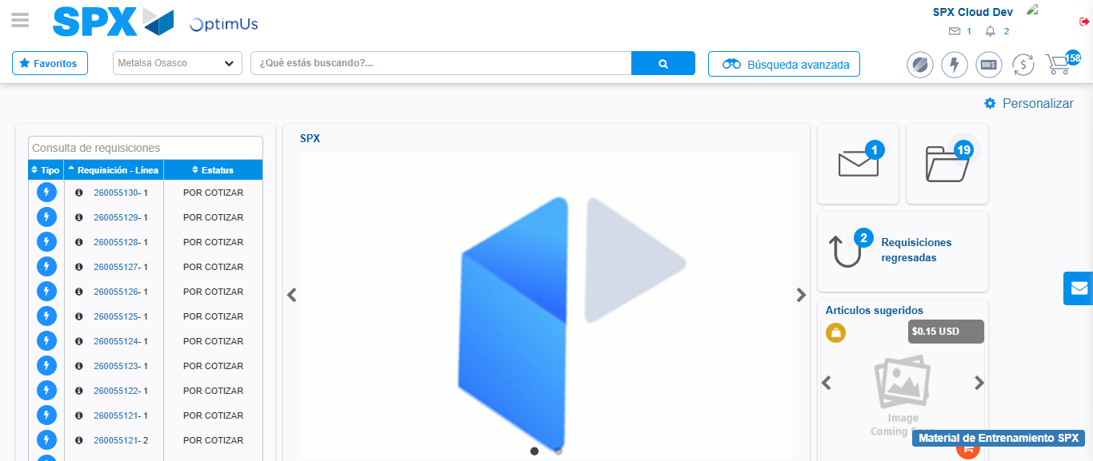Image file-name: QC_Testing-tc002_SPX_Dev5_Crear_Requisicion_Spot_Con_FAD_Tipo_Cobro_CC-1790177450149

Step 9 - Log Out : Log Out SPX
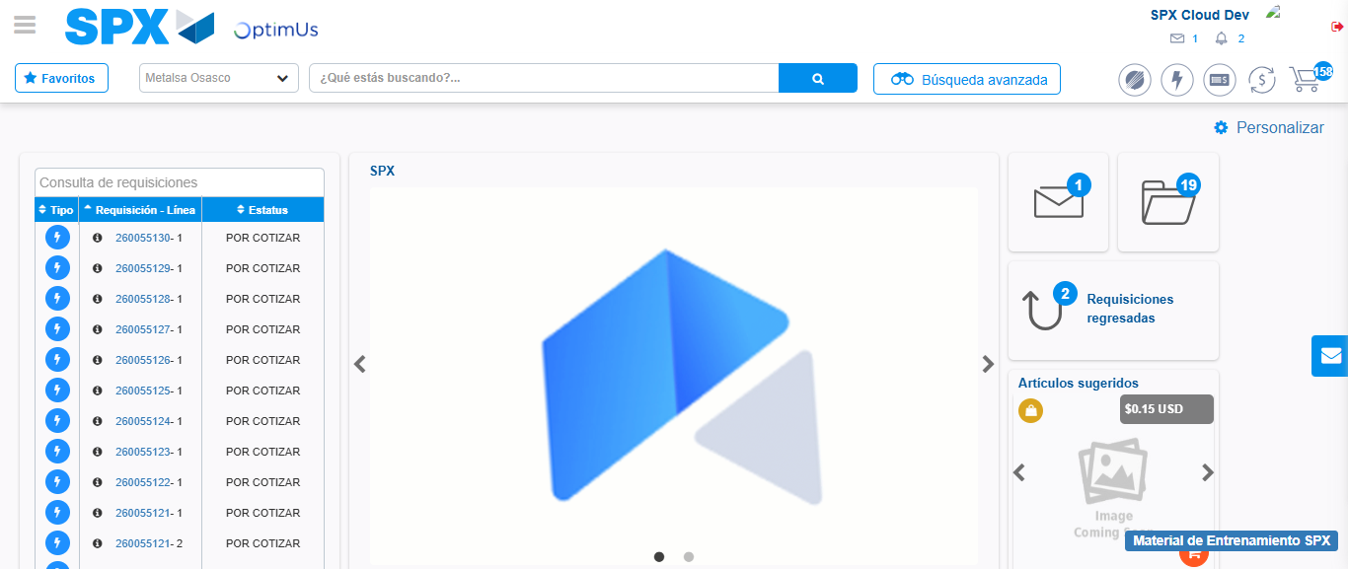Image file-name: QC_Testing-tc002_SPX_Dev5_Crear_Requisicion_Spot_Con_FAD_Tipo_Cobro_CC-1790177450412

